LAB 4

TITLE: Implementation of Round Robin (RR) CPU Scheduling Algorithm in C

OBJECTIVE:
To implement Round Robin Scheduling algorithm using C, and calculate:
- Waiting Time (WT)
- Turnaround Time (TAT)
- Average Waiting Time
- Average Turnaround Time

THEORY:
Round Robin (RR) is a preemptive CPU scheduling algorithm that assigns a fixed time quantum to each process in the ready queue. Processes are executed in a circular (round-robin) order.

Characteristics:
- Every process gets equal share of CPU time (quantum).
- If a process doesn’t finish in its time quantum, it is sent to the end of the queue.
- Fair and starvation-free scheduling.
- Preemptive in nature.

Terminologies:
- Burst Time (BT): Total time required by a process to complete.
- Time Quantum: The fixed time allocated to each process in each cycle.
- Waiting Time (WT): Total time a process waits in the ready queue.
- Turnaround Time (TAT): Total time from arrival to completion.
  - TAT[i] = BT[i] + WT[i]
- Average Waiting/Turnaround Time:
  - AWT = ∑WT / n, ATAT = ∑TAT / n

Algorithm:
- Input number of processes n and time quantum q
- Input burst time for each process
- Initialize remaining burst time = burst time
- Loop through processes in order:
- If remaining time > quantum:
  - Execute for q time
  - Subtract quantum from remaining
- Else:
  - Execute remaining time
  - Set waiting time = current time - original burst time
  - Mark process as complete
- After all processes are complete, calculate turnaround time:
- TAT[i] = BT[i] + WT[i]
- Compute average WT and TAT
- Display result

PROGRAMS
#include <stdio.h>

int main() {
int n, quantum;
printf("Enter total number of processes: ");
scanf("%d", &n);
printf("Enter time quantum: ");
scanf("%d", &quantum);

int burst_time[n], waiting_time[n], turnaround_time[n], remaining_time[n];
int i, time = 0, completed = 0;

// Input burst times
for(i = 0; i < n; i++) {
printf("Enter burst time for process P%d: ", i + 1);
scanf("%d", &burst_time[i]);
remaining_time[i] = burst_time[i];
waiting_time[i] = 0;
}

// Round Robin scheduling
while(completed < n) {
for(i = 0; i < n; i++) {
if(remaining_time[i] > 0) {
if(remaining_time[i] > quantum) {
time += quantum;
remaining_time[i] -= quantum;
} else {
time += remaining_time[i];
waiting_time[i] = time - burst_time[i];
remaining_time[i] = 0;
completed++;
} } } }

// Calculate turnaround times
float avg_waiting = 0, avg_turnaround = 0;
for(i = 0; i < n; i++) {
turnaround_time[i] = burst_time[i] + waiting_time[i];
avg_waiting += waiting_time[i];
avg_turnaround += turnaround_time[i];
}

avg_waiting /= n;
avg_turnaround /= n;

// Display results
printf("\nProcess\t\tBurst Time\tWaiting Time\tTurnaround Time\n");
for(i = 0; i < n; i++) {
printf("P%d\t\t%d\t\t%d\t\t%d\n", i+1, burst_time[i], waiting_time[i], turnaround_time[i]);
}

printf("\nAverage Waiting Time: %.2f\n", avg_waiting);
printf("Average Turnaround Time: %.2f\n", avg_turnaround);

return 0;
}

Output:
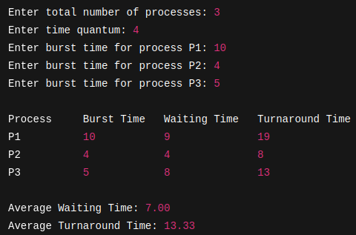

RESULTS:
The Round Robin Scheduling Algorithm was successfully implemented. The program correctly calculated the waiting time, turnaround time, and their averages using a fixed time quantum.

CONCLUSION:
Round Robin is a fair and efficient scheduling technique used in time-sharing systems. This lab demonstrated how preemptive execution can be handled using time slices and how turnaround and waiting time are affected by time quantum.

